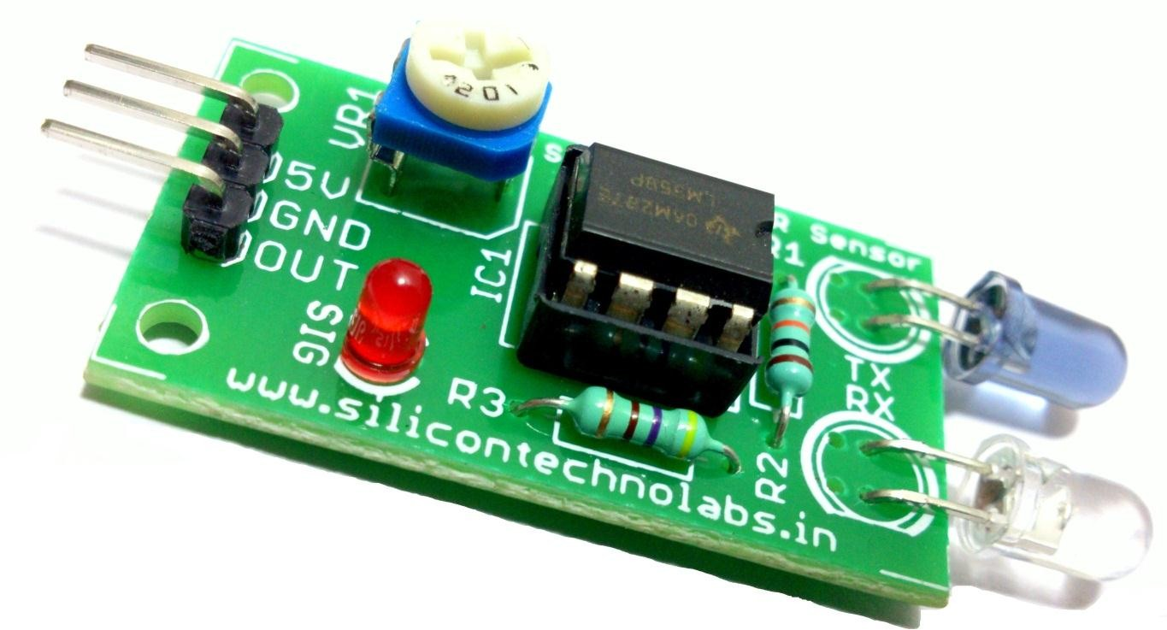

*IR Proximity Sensor*

# Descriptions

The Multipurpose Infrared Sensor is an add-on for your line follower robot and obstacle avoiding robot that gives your robot the ability to detect lines or nearby objects. The sensor works by detecting reflected light coming from its own infrared LED. By measuring the amount of reflected infrared light, it can detect light or dark (lines) or even objects directly in front of it. An onboard RED LED is used to indicate the presence of an object or detect line. Sensing range is adjustable with inbuilt variable resistor.

The sensor has a 3-pin header which connects to the microcontroller board or Arduino board via female to female or female to male jumper wires. A mounting hole for easily connect one or more sensor to the front or back of your robot chassis.

# Features

* + 5VDC operating voltage.
  + I/O pins are 5V and 3.3V compliant.
  + Range: Up to 20cm.
  + Adjustable Sensing range.
  + Built-in Ambient Light Sensor.
  + 20mA supply current.
  + Mounting hole.

# Specifications

* + Size: 50 x 20 x 10 mm (L x B x H)
  + Hole size: φ2.5mm

# Schematics

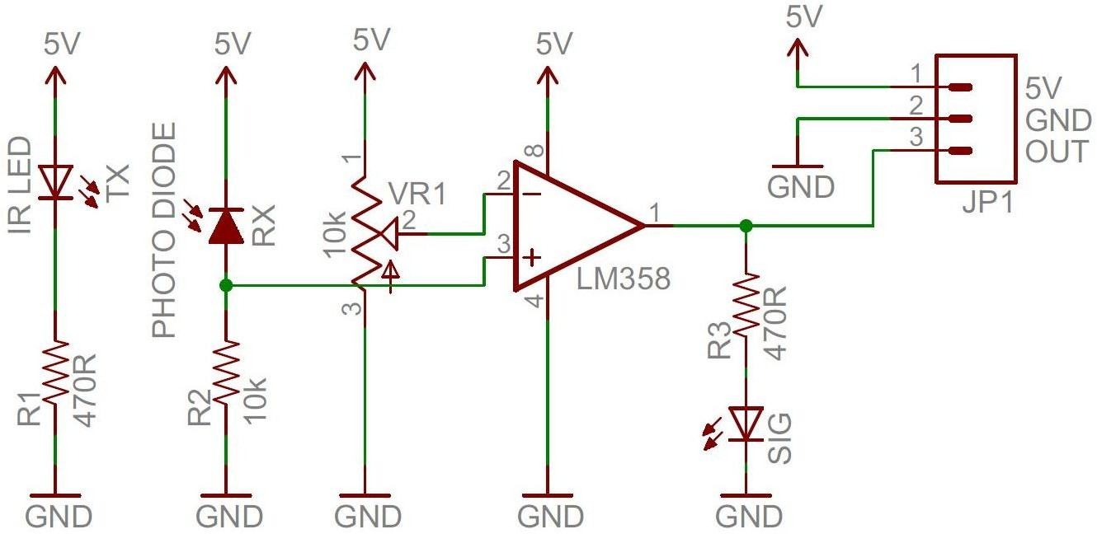

1. **Hardware Details**

## Variable Resistor To set range of sensor

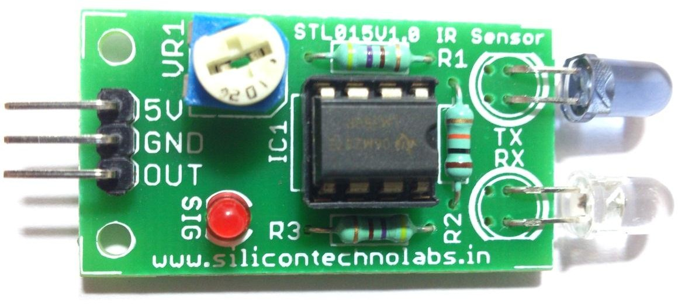

(0-20cm)

Surface

## 5V DC

IR Transmitter

## GND

Digital Output to Arduino or Microcontroller Input

## IR Receiver

Reflected Rays

# Interface to Arduino

Now let’s we build simple object counter using IR Proximity Sensor that’s counts the Number of objects.Connect Silicon TechnoLabs IR Proximity Sensor to your arduino board as shown in below image.

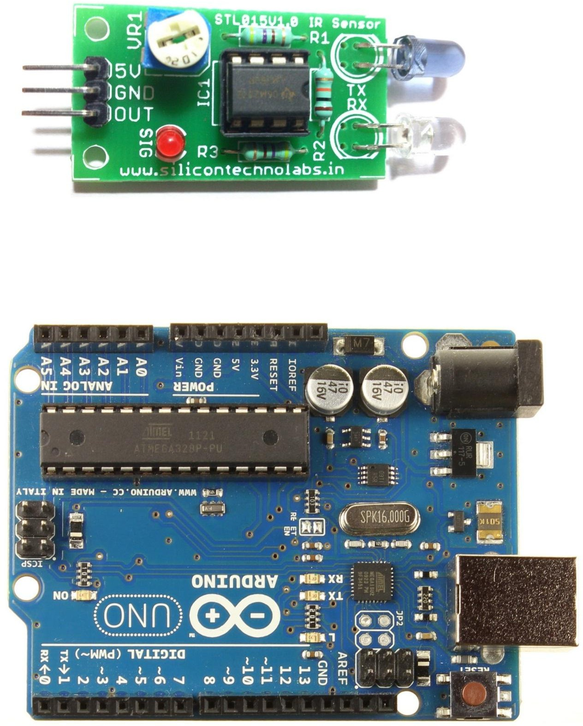

# Arduino Sample Code

/*

Object counter

Counts the number of objects and prints the results to the serial monitor. The circuit:

* OUT attached to pin 2 Created 2015

by Harshit Borad <[http://www.silicontechnolabs.in>](http://www.silicontechnolabs.in/)

*/

// constants won't change. They're used here to

// set pin numbers:

const int OUT = 2; // the number of the IR Proximity Sensor pin const int ledPin = 13;// the number of the LED pin

// variables will change:

int Number_of_Object = 0;// variable for reading the Number of Objects passing from sensor int SensorState = 0;

void setup()

{

Serial.begin(9600); // initialize serial communications at 9600 bps: pinMode(ledPin, OUTPUT); // initialize the LED pin as an output: pinMode(OUT, INPUT); // initialize the IR Proximity Sensor pin as an input:

}

void loop()

{

SensorState = digitalRead(OUT);// read the state of the Sensor Signal

// check if the Sensor Signal is HIGH then there is object in front of sensor

// so increment Number_of_Object variable by one. if (SensorState == HIGH)

{

digitalWrite(ledPin, HIGH);// turn LED on: Number_of_Object++;

Serial.println(Number_of_Object);// print the results to the serial monitor:

}

else

{

digitalWrite(ledPin, LOW);// turn LED off:

}

}

**Thank you**

**“Happy Coding”**